Sri Lanka Institute of Information Technology

**IT24102793**

**Jayathunaga C.D**

**IT2120 - Probability and Statistics**

B.Sc. (Hons) in Information Technology

**1.**

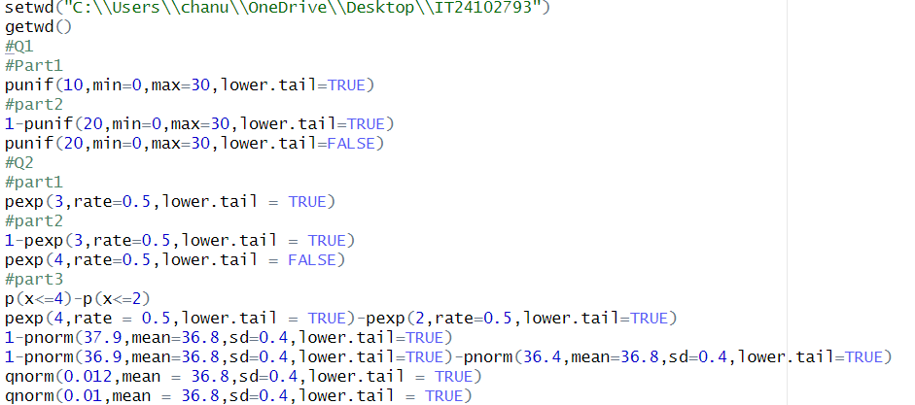

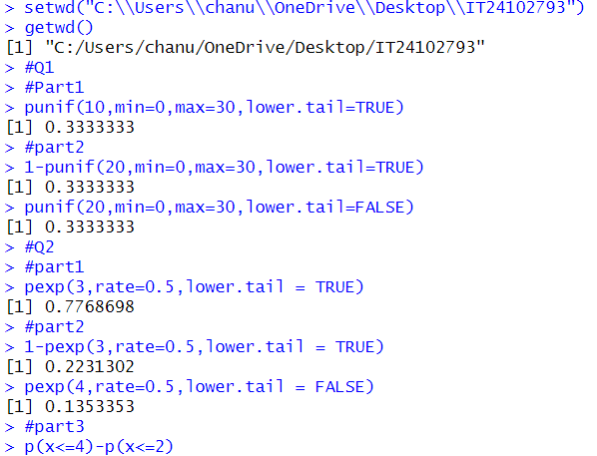

**Exercise**

